

**Condition Based Monitoring Program Setup Guide**

*Version 0.3 – 3-axis*

Created: 11/01/2019

Author: Sharkey, Tom

Last Modified: 28/01/2021

Modified by: Sharkey, Tom

# Contents

1 Contents 2

2 Overview 3

3 Components 5

3.1 Hardware Kit 5

3.2 Software Requirements 5

4 Software Setup 6

4.1 Executable Setup 6

4.2 Python Setup 7

4.2.1 Python 2.7 7

4.2.2 Pip Installations 8

4.2.3 CbM installation 12

5 Hardware Setup 13

6 Features & Functions 18

6.1 GUI 19

6.1.1 Motes 19

6.1.2 Mode 20

6.1.3 Action 22

6.1.4 Alarm setting 23

6.1.5 Reset 25

6.1.6 Settings 26

6.1.7 Help 30

6.2 Command Window 32

7 Support 33

7.1 Installing updates 33

7.1.1 Crosscore 33

7.1.2 Hex File 34

7.1.3 Installing and resetting the mote 35

7.1.4 Putting it all together 38

7.2 Mounting Information 41

7.2.1 Mounting Studs 41

7.2.2 Magnetic Mounts 42

7.3 Troubleshooting 43

# Overview

This document will give a high-level explanation of the function and setup of Analog Devices’ Condition Based Monitoring (CBM) evaluation software and hardware. This includes a brief introduction to the software and how it is used with the CBM hardware. It also includes a step-by-step guide on the functionality of the CBM Graphical User Interface (GUI).

The function of the system is to provide an evaluation tool for a wireless signal chain for MEMS accelerometer-based vibration monitoring. The hardware can be directly attached to a motor or fixture, either magnetically or via a stud.

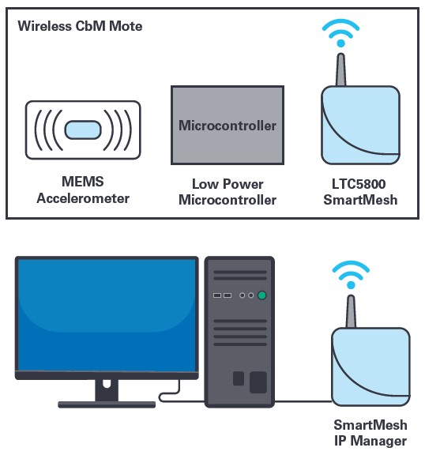 *Figure 1: SmartMesh layout*

The CBM hardware signal chain consists of a tri-axis ADXL356 accelerometer mounted to the base of the module. The output of the ADXL356 is read into the AD7685 ADC, and then processed by the ADuCM4050 low-power microcontroller. Here it is buffered, transformed to the frequency domain and streamed to the SmartMesh IP mote. From the SmartMesh chip it is wirelessly streamed to the SmartMesh IP Manager. The manager connects to a PC and visualization and saving of the data can take place.

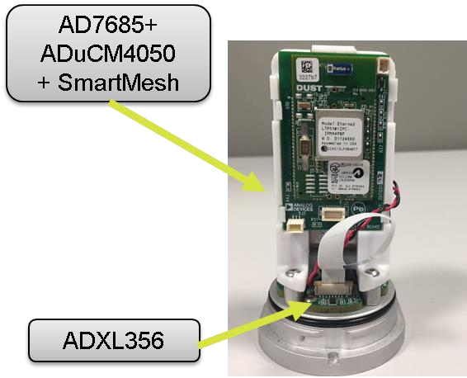

*Figure 2: 3-axis mote breakdown*

# Components

## Hardware Kit

* SmartMesh IP Manager (DC2274A)
* EV-CBM-VOYAGER3-1Z Hardware Module (referred to as “Mote”)
* JTAG Cable (only needed for firmware upgrade)

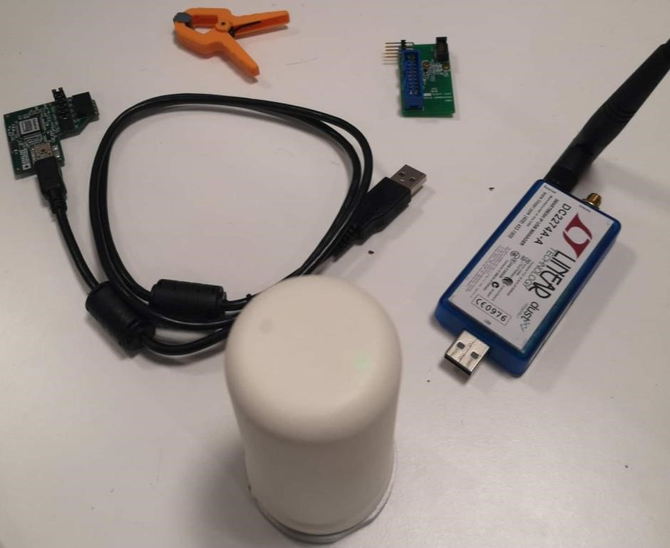

*Figure 3: Hardware Required*

## Software Requirements

For Python Install:

* Python 2.7.15
* Pip for Python
* Matplotlib
* PySerial
* Scipy
* Pandas
* openpyxl
* CBM_app (provided)

For Exe Install (Windows Only):

* CBM_app.exe

# Software Setup

## Executable Setup

This setup is suitable for Windows users only and is not guaranteed to work for every machine. It requires little installation as an executable has been created to do this work for you.

* Open the folder which contains CBM_app.exe.
* Double click on the .exe.

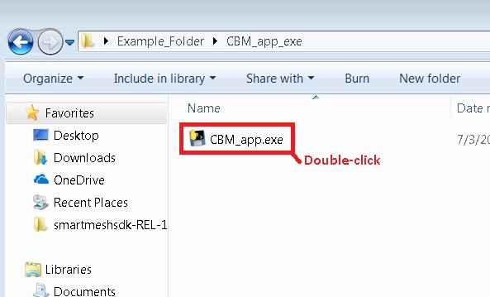

*Figure 4: Run Executable*

The program launches for you automatically. It can be a little slow to launch (up to 1 minute), particularly the first time it is done. If the program does not launch, the executable may not be suited to your machine. The python setup may be used instead.

## Python Setup

**PLEASE NOTE: If the executable setup 4.1 has succeeded for you, these steps are not necessary.**

### Python 2.7

* Navigate to the downloads page of python.org, <https://www.python.org/downloads/release/python-2715/>
* Download the appropriate version of python i.e. 2.7.15: Windows, Linux ….
* If you wish to use a version of Python that is not 2.7, consult the Troubleshooting section of this guide. Be aware, the code has not been tested outside of Python v2.7.
* Python IDLE was the environment used to write this program, and should function correctly if all these steps are followed correctly. The same procedure does not guarantee success for other Python Environments (such as PyCharm).

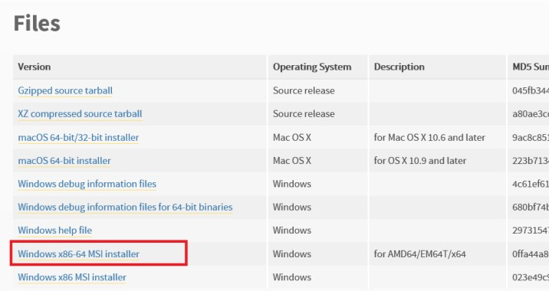

* Run Python’s installation setup, installing it for **a single user only**.

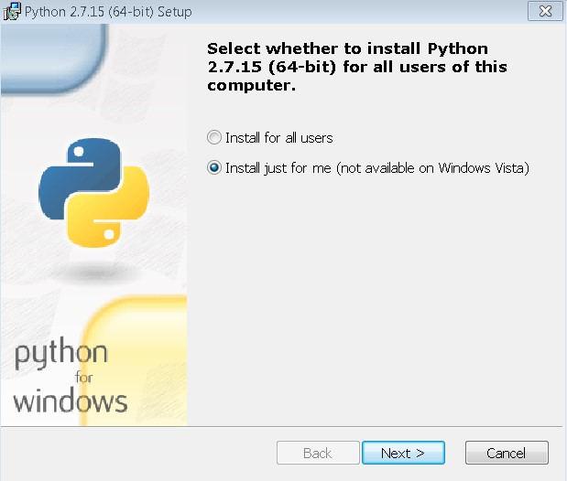

* Check for installation by searching python in search bar, checking if IDLE appears.

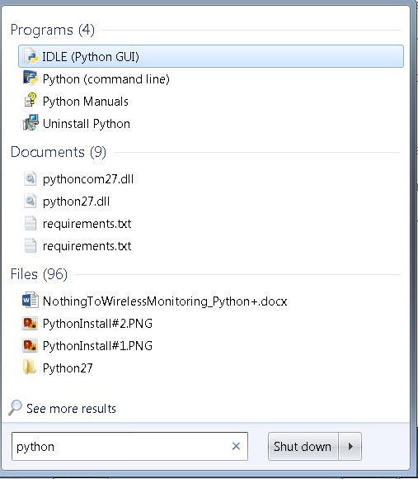

### Pip Installations

* Pip is installed for you in the folder C:/Python27/Scripts (if you have installed and saved Python correctly).
* To use pip you must navigate to this folder as follows:
* Navigate to C:/ by hitting the windows key, then clicking “computer”.

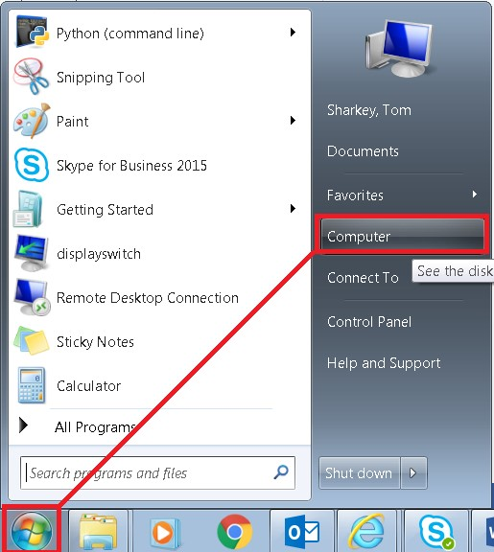

* Double click **DRIVE_C (C:/)**.

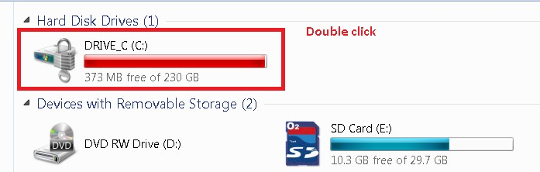

* Double click **python27.**

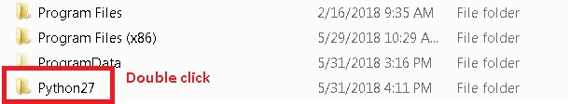

* Double click **Scripts.**

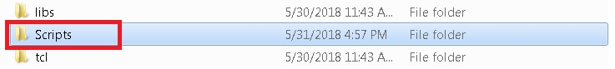

* Then on any white space in the window, press shift and right click, as shown below.
* Now click “open command window here”. This opens the cmd in this directory.

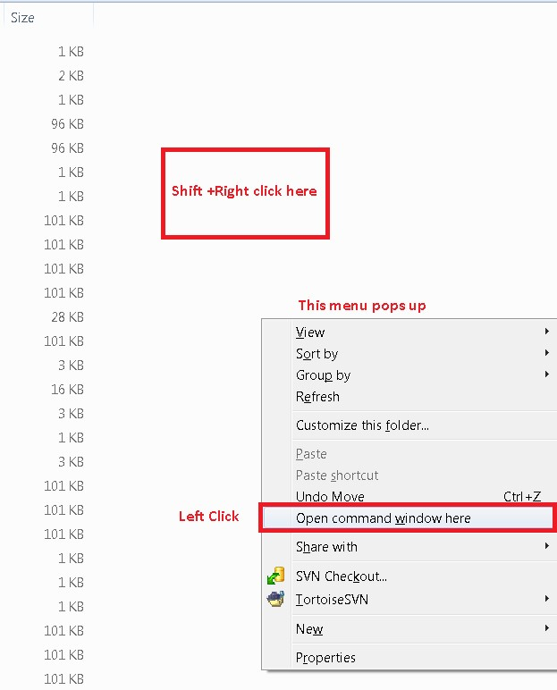

* The command window should now say C:/Python27/Scripts> , which indicates that you are in the correct folder.

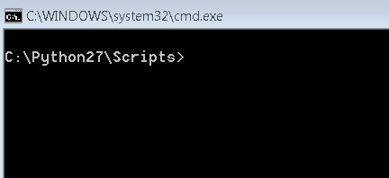

* The basic command for each module installed will be

$$pip install<filename>$$

The modules to be installed for the version of this software indicated on the cover of this document are:

* Pyserial (v2.7)
* Matplotlib (v2.2.3)
* scipy (v1.2.2)
* pandas (v0.23.3)
* openpyxl (v2.6.4)

Please note, the version numbers included are simply the ones used in the tested setup. The most recent versions should suffice and will be installed if the pip install command is used.

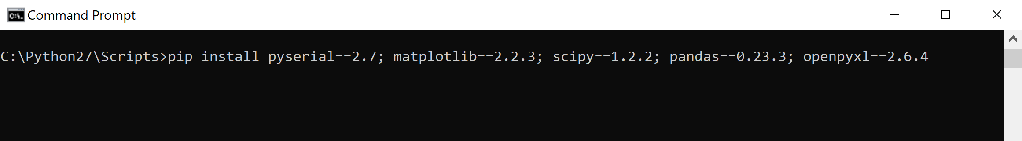

Note, the module names are divided by a semicolon (;)

Alternatively, each of these modules can be installed individually.

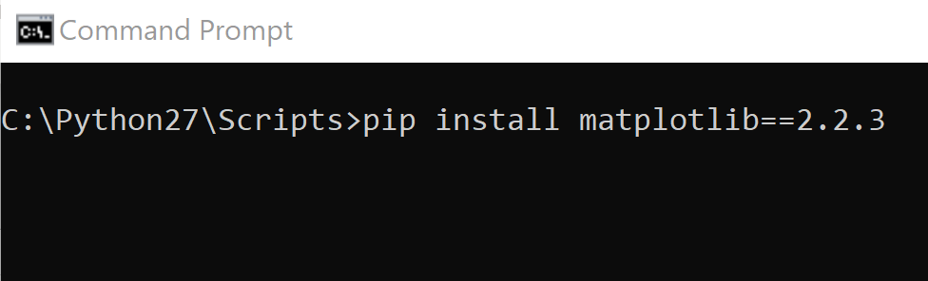

### CbM installation

* Open the folder containing this word doc, open the folders app 🡪 Simple, and then double click on the app shown called “CBM_app”.
* This may ask you to choose a program. Simply right click the file instead 🡪 open with 🡪 and choose python from the pop up list.

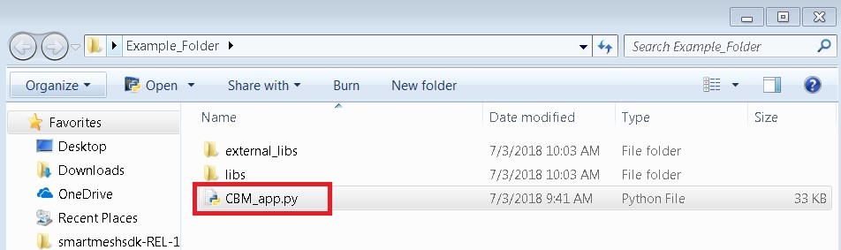

* The screen below pops up. This is the graphical interface for the program. Leave this open for the next set of steps.

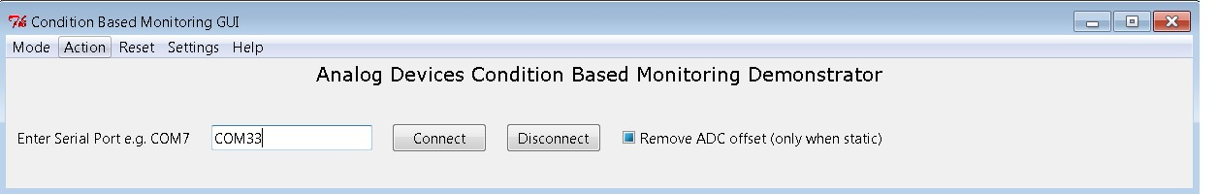

*Figure 5: Completed GUI setup*

# Hardware Setup

* Connect the wireless manager to any USB port on your computer.
* As this is a new device, the drivers for it may take a few minutes to install. It is important that this step happens before the mote is powered up.
* If you have purchased your own manager, there are additional steps which are outlined in Troubleshooting.

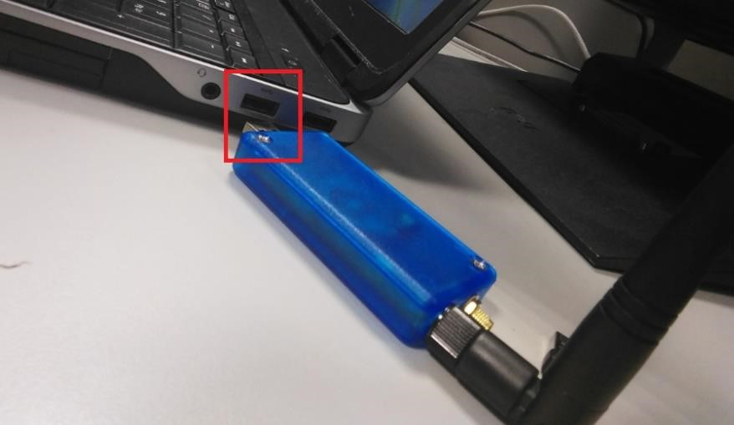

*Figure 6: Inserting manager into USB port*

* Power up the mote by inserting the provided batteries.
* **CAUTION: Note the polarity of the batteries in the mote.** The positive + end should be attached to the side with the **RED** wire.
* The negative – end should be attached to the side with the **BLACK** wire. Failure to do so could result in device damage.

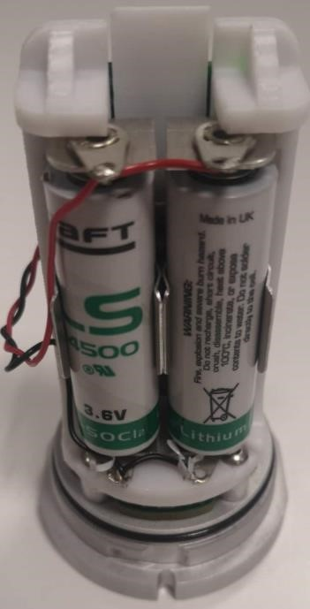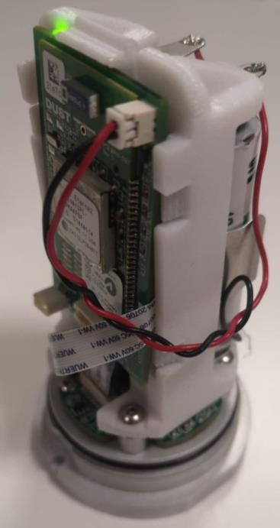

*Figure 7: Mote with Batteries, uncovered*

* Put batteries in the wireless mote and **wait** for the steady green light to begin **flashing.** This is the network establishing automatically.
* Be patient, this takes on average: **2-3 minutes** to complete.

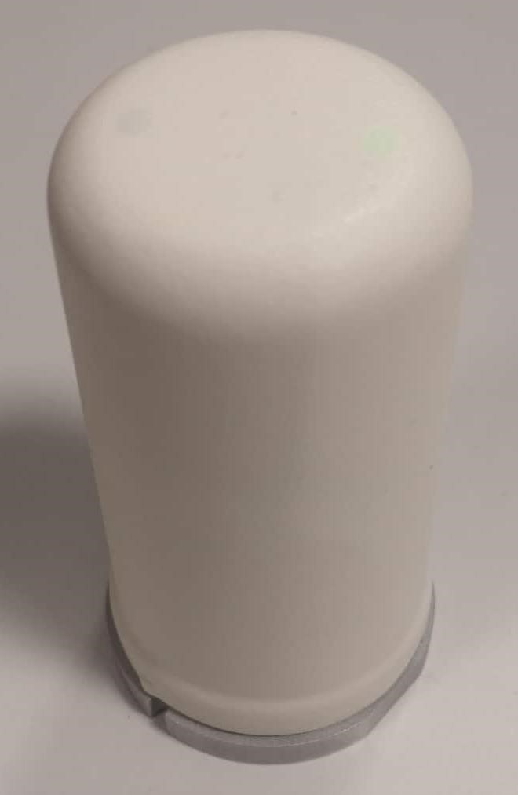

*Figure 8: Mote with Cover*

* Use your search bar to open **device manager** on the computer and scroll down to **Ports (COM & LPT).**

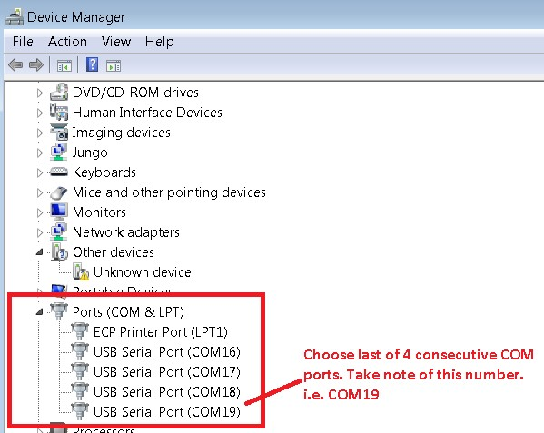

*Figure 9: Device Manager*

* Click the arrow. There should be 4 COM ports in sequential order as shown above i.e. COM16, COM17, COM18, and COM19.
* If these ports do not appear a few minutes after you have plugged the manager in, please consult the guide on analog.com [http://www.analog.com/media/en/technicaldocumentation/user-guides/smartmesh_ip_tools_guide.pdf](http://www.analog.com/media/en/technical-documentation/user-guides/smartmesh_ip_tools_guide.pdf) , Section 3.2 for troubleshooting driver installation for the FTDI drivers.
* Choose **the last of these four** COM ports. e.g. COM19.
* Enter this number in your new program as shown and click connect.

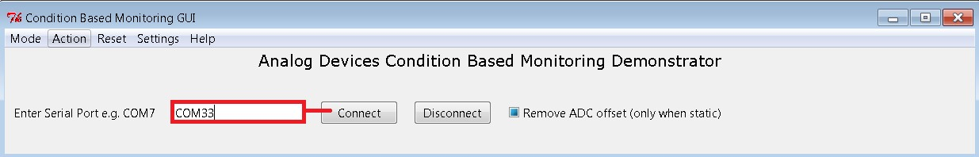

*Figure 10: Enter 4th COM*

* The graph of the mote appears on screen, as well as some connection information.

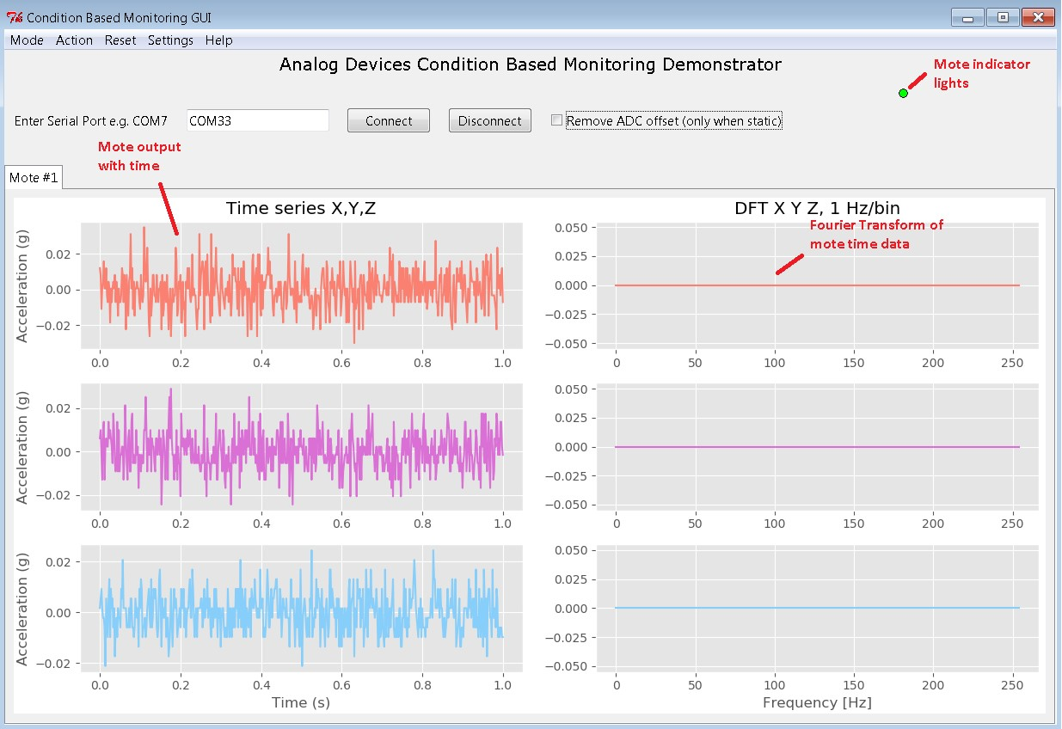

*Figure 11: Mote time series output*

* To calibrate the device, place it somewhere steady, with little movement, and click

“remove ADC offset”.

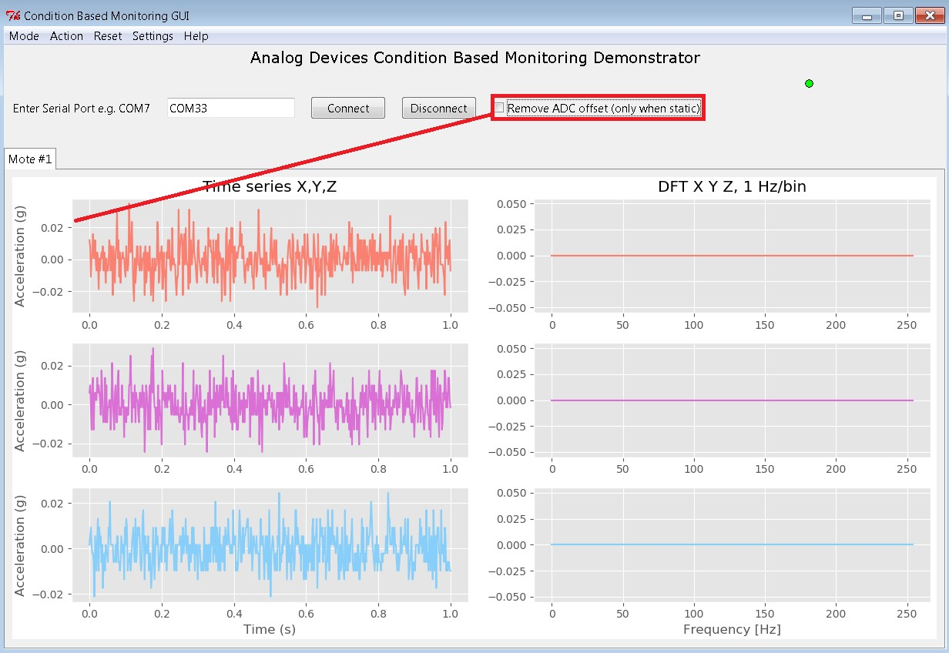

*Figure 12: Removing ADC offset*

* If you have trouble connecting to the mote, take the battery out and put it back in again.

You can also try closing and opening ‘CBM_app’ again.

* You have completed the installation of this program and its associated modules.
* Please note, when connecting the manager and mote in future, it is preferable to **plug in the manager before powering the mote**.

# Features & Functions

With your mote and manager connected, and the CBM_app software running, there are several functions available to you.

The software opens, displaying a plot of the acceleration of the motes against time in addition to a graph which plots the Discrete Fourier Transform (DFT) of the time series plots.

Please note that the software is intended for vibration measurements in industrial machinery and as such, requires some level of g force to indicate any meaningful change on the graphs. To check operation manually, shake the mote for 4 to 5 seconds to show changes on the graph.

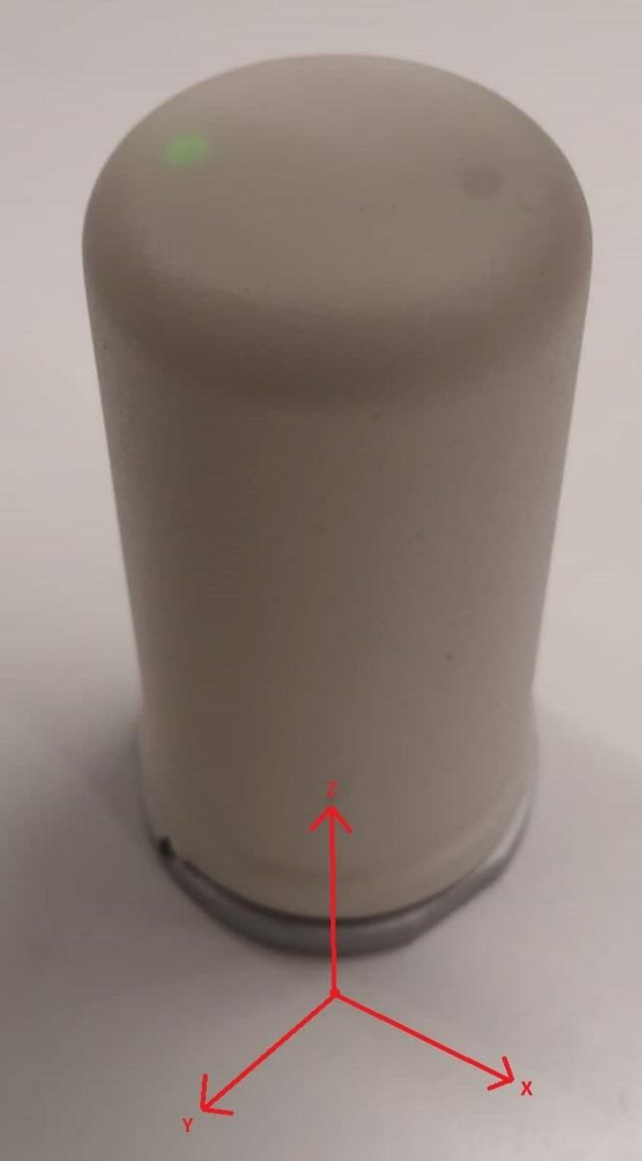

*Figure 13: Axis of ADC acceleration*

## GUI

The graphical user interface, or GUI, refers to the main window upon which the plots and options are being displayed. The GUI can currently display the information of multiple motes, but the user may experience program slowness with more than 3 motes connected.

### Motes

In the upper right corner, a number of green LEDs displays the number of connected motes.

The GUI displays mote plots in the form of a “Notebook”. This means that clicking on the “Mote #2” tab will update the GUI to display the plots from that mote. Currently a tab will not start plotting mote data until the user first switches to that tab.

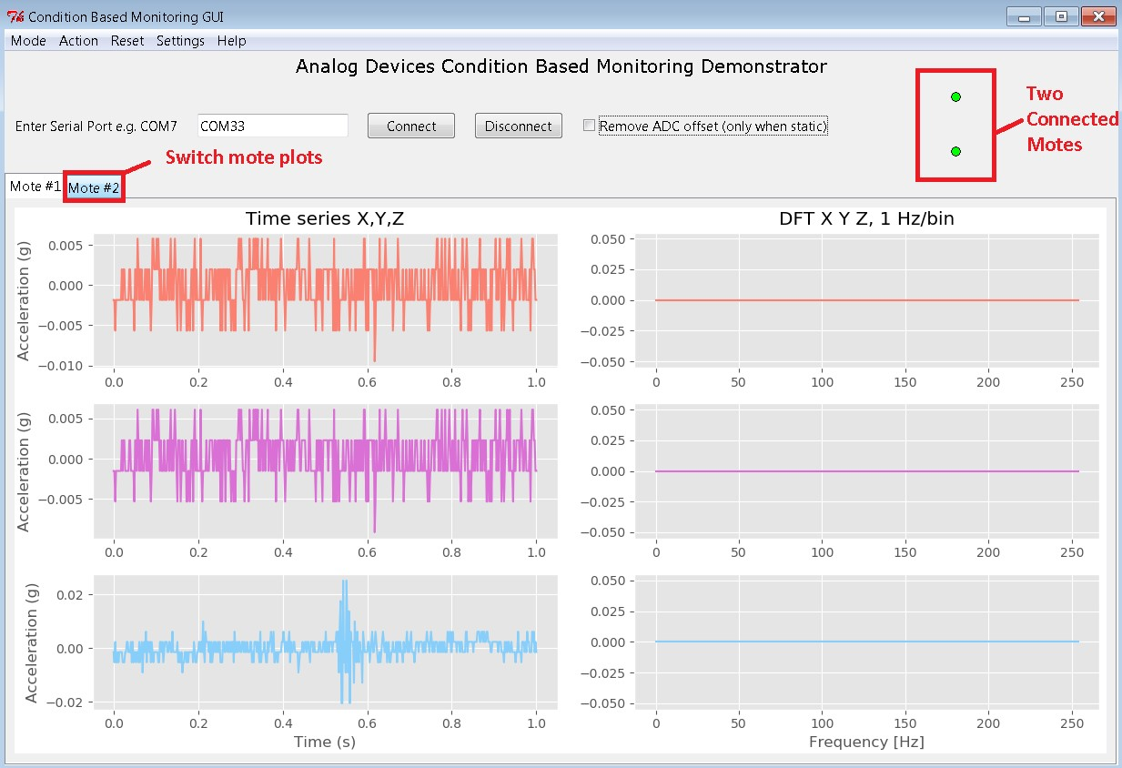

*Figure 14: Switch Mote Plots*

### Mode

First, observe in the top left corner of the window, a dropdown button labelled “Mode”. This button, when clicked, lists a number of options for plots which can be displayed in place of the DFT. Selecting “peak” for example, will display the largest measured acceleration of the mote(s) over time. You are encouraged to explore the other modes, which all analyse the data from the time series plot in a different way.

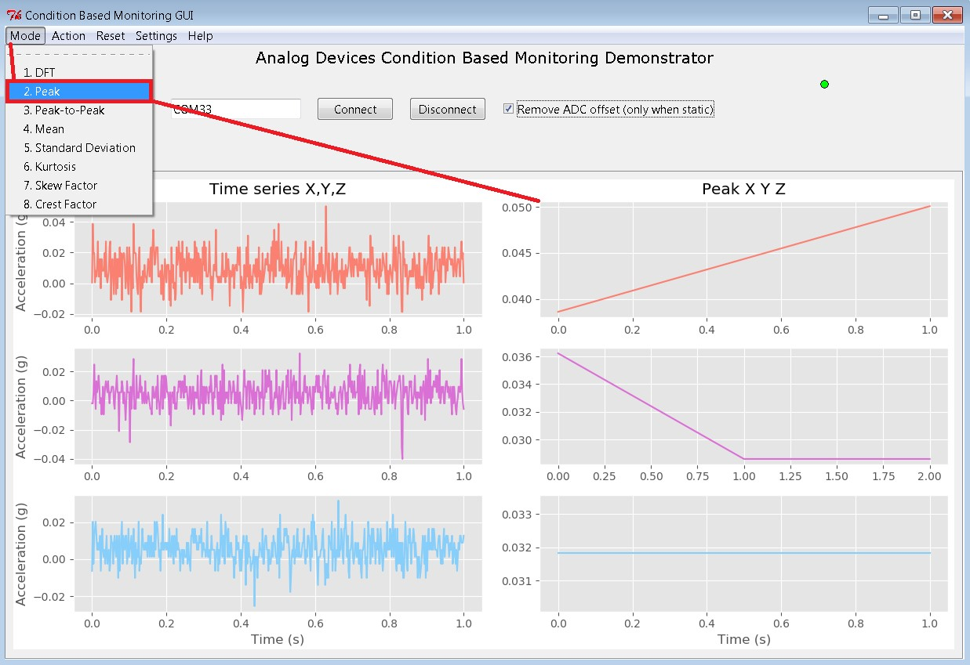

*Figure 15: Changing the mode*

|  |  |
| --- | --- |
| **Mode** | **Explanation** |
| **DFT** | Discrete Fourier Transform. Conversion of time domain data to the frequency domain. Gives clearer representation of source of vibration acting on the mote. Rotation of motor seen at lower frequencies, bearing faults seen at higher frequencies. |
| **Peak** | Measures the max value achieved for each plot of time domain data (512 values), and plots this value on graph. |
| **Peak-to-Peak** | Similar to peak, measures difference between max and min value achieved by time domain data (512 values), and plots this value on graph. Typical value is twice that of “peak” value. |
| **Mean** | Calculates the root mean square (rms) value of the time series data (512 bits). This is the average value of the time domain data if all values are made positive. |
| **Standard Deviation** | Measures of the average distance of a time series data point from the mean. |
| **Kurtosis** | Kurtosis indicates whether outliers are infrequent and extreme (high kurtosis), or frequent and moderately sized (low kurtosis). The kurtosis value plotted is “Excess kurtosis”, for which the normal distribution has a value of 0. Deviations from a zero value for kurtosis can be used to indicate a bearing fault. |
| **Skew Factor** | Indicates the “slant” of the signal when sorted into a probability density function. A negative skew indicates a long “tail” to the left of the function. |
| **Crest Factor** | Indicates how extreme the peaks are in a waveform. The greater the crest factor, the greater the energy contained in higher frequency harmonics. Higher frequency harmonics are often used to mark bearing issues |

*Table 1: Statistical Functions*

For a more in-depth explanation of these functions and their use in the program, please consult the companion document included, “Condition Based Monitoring Statistical Functions”.

### Action

Next, there is the “Action” dropdown. This allows you to open a menu, and select a number of data sets to be saved to an SQL database. The program saves time and DFT data, as well as each of the “mode” values. This data is saved to an SQL file named “motedata.db” which is created in the same directory as the program is running.

After saving has been completed, this SQL database can be converted to an excel file using the “Convert to Excel” button. Depending on the size of the SQL file this may take some time. The information in the SQL file (saved as DB file) can be viewed only using a database browser, available online: [https://sqlitebrowser.org/dl/.](https://sqlitebrowser.org/dl/) Simply download the program that suits your operating system anywhere on your computer. Then navigate to the “motedata.db” file 🡪 right click 🡪 Open with 🡪 DB Browser.

Please note, if the program saves data on many different occasions, it always saves to the same database file “motedata.db”. This file must be deleted manually if you wish to start saving to an empty database.

**NOTE:** Hit “Enter” to save the data to the SQL database before converting to excel.

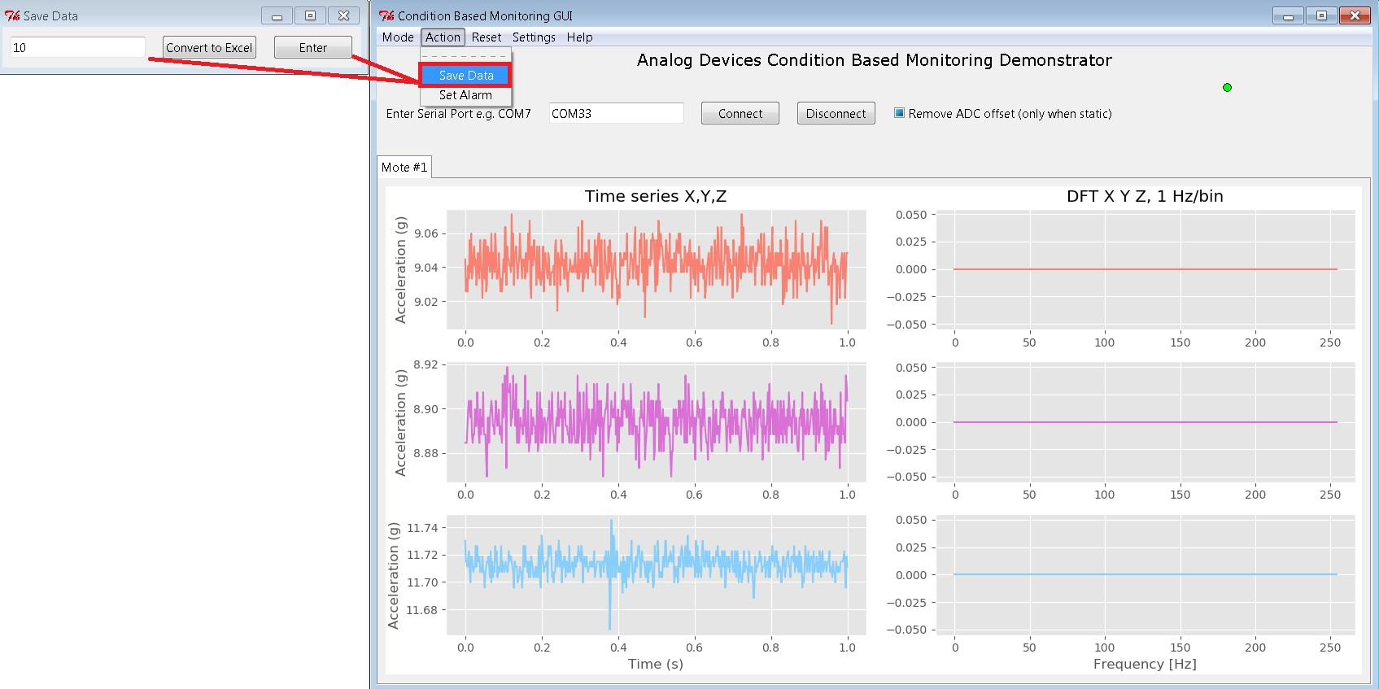

*Figure 16: Save Data*

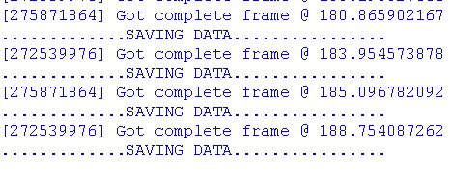

*Figure 17: GUI confirmation of saving*

### Alarm setting

Under Action > Set Alarm, there is a pop up menu which allows the user to set limits on a single value that a mote should reach. This means for example that a mote should not exceed 1g acceleration peak value. If this value is exceeded, a red LED on the mote lights, and the GUI indicates that an alarm has been triggered. This does not affect mote transmission, the mote continues to transmit as normal after the alarm has been triggered.

The reset button is used to reset the LED on the mote to a blinking green.

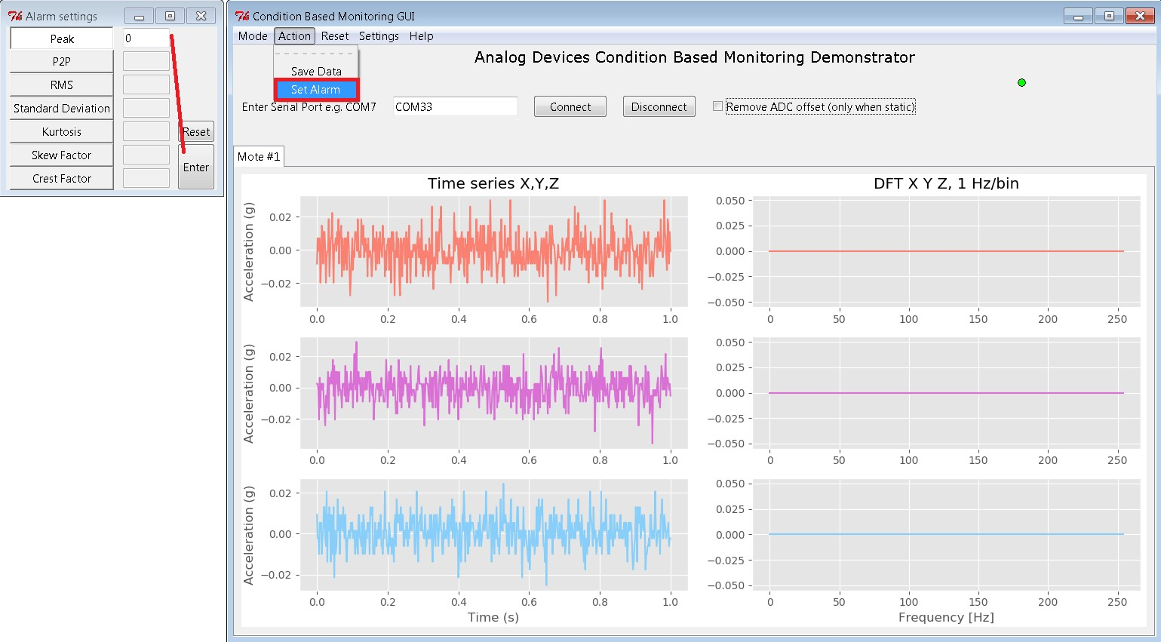

*Figure 18: Setting Alarms*

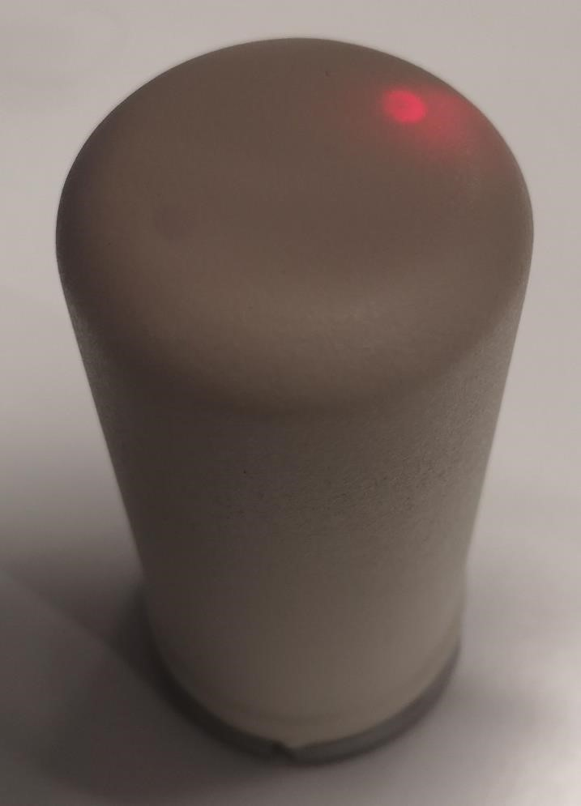

*Figure 19: Mote with alarm triggered*

### Reset

“Reset” is a dropdown that offers you the option to clear all previously recorded data in the mode plots, such as “peak”, “mean”, “kurtosis”, etc. This clears the plots, which will again gradually fill as data from the motes is received.

This function is useful in allowing you to remove the results recorded which contain the “ADC offset voltage” i.e. before you have clicked and unclicked the “Remove ADC offset” button.

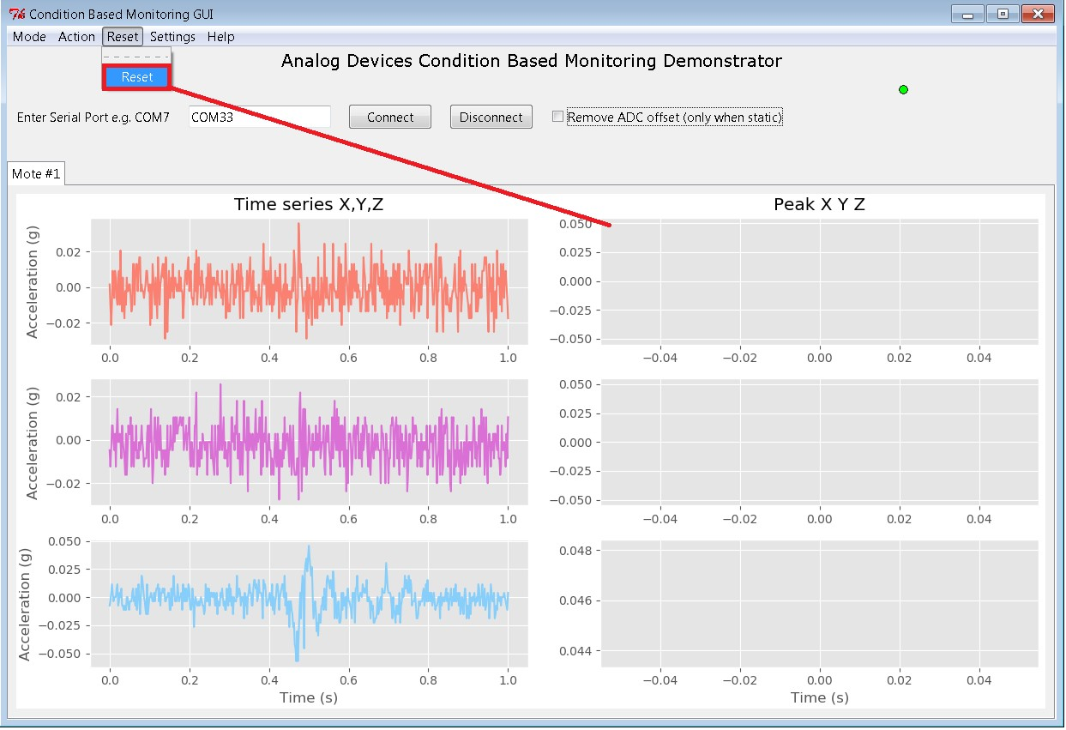

*Figure 20: Resetting Graphs*

### Settings

The “Settings” dropdown opens a menu through which you can set a number of important parameters for the incoming mote data.

Please note, changing these settings alters the configuration of the ADC. Therefore, you must **remove the offset again** after changing these settings.

*Sampling:*

The **sampling frequency** setting changes the number of data points collected per second. A higher sampling frequency will result in a smaller time-window being displayed, for example:

* 1s for 510Hz
* 0.5s for 1000Hz

The ADXL356 bandwidth is 2.4kHz, so sampling frequency should **optimally be 5kHz** or higher. Sampling at lower frequencies is possible by changing the settings but please be aware of the **danger of aliasing**. By default, the sampling frequency is chosen as 510Hz. This sampling frequency was chosen for demonstration purposes, as it shows roughly one second of time data.

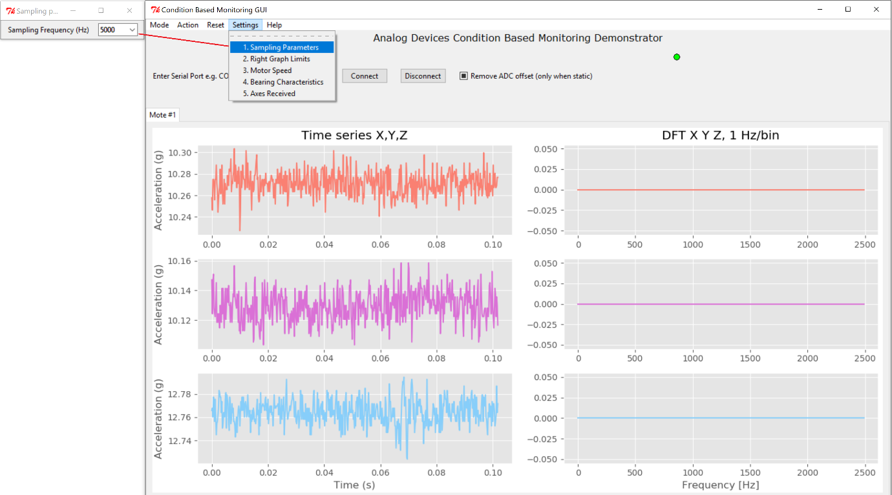

*Figure 21: Sampling parameters*

*DFT Axis:*

DFT axis allows the user to **set the boundaries for the DFT plot**. This allows the user to focus in on a particular set of values.

The user manually sets the values for

**X-Axis** start and end

**Y-Axis** start and end

If auto is selected, the plot will automatically scale to the data.

Take special care to choose values small enough to see the data.

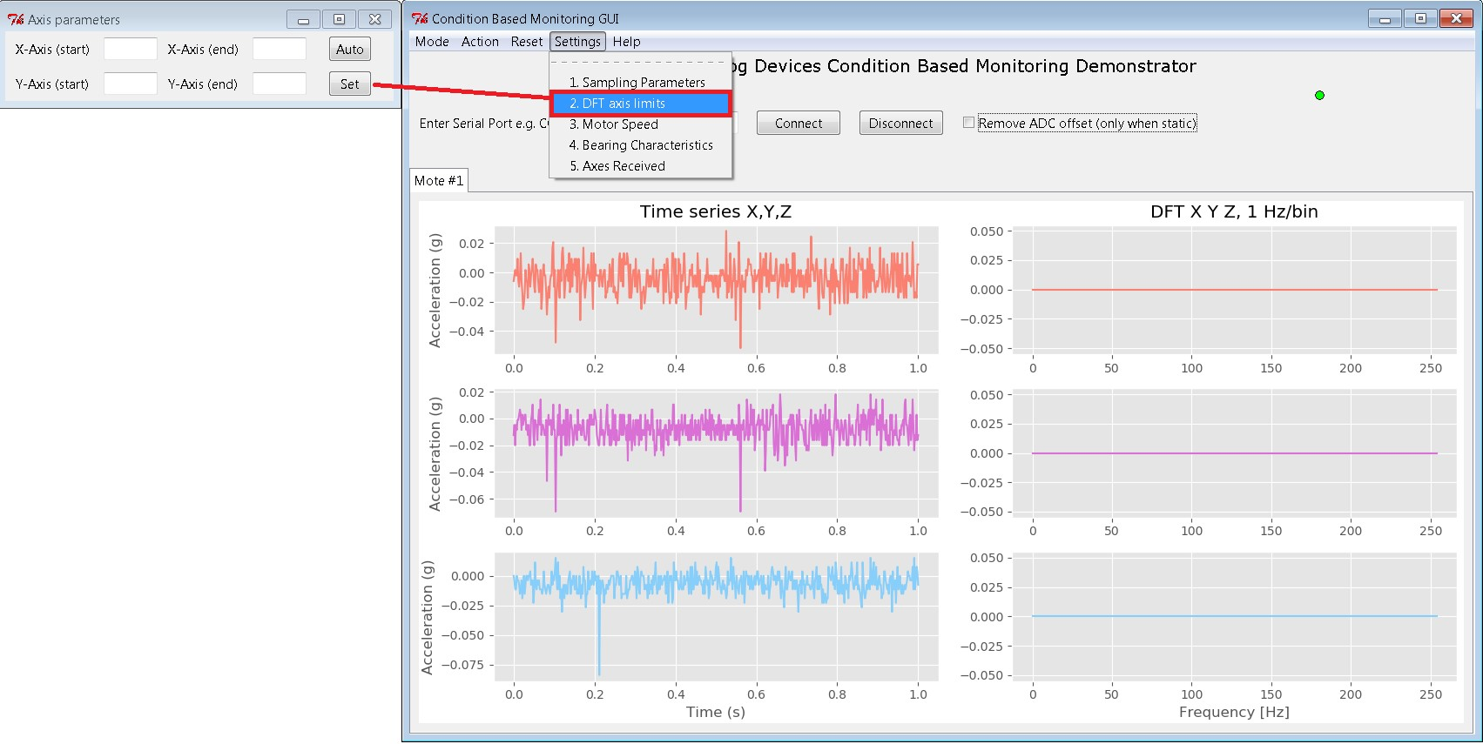

*Figure 22: DFT axis*

*Motor markers*

This option allows the user to enter default values for a motor to plot where spikes in frequency are expected to occur, for a motor at a specified RPM. This places markers on the DFT plot that can be compared to real data for a motor.

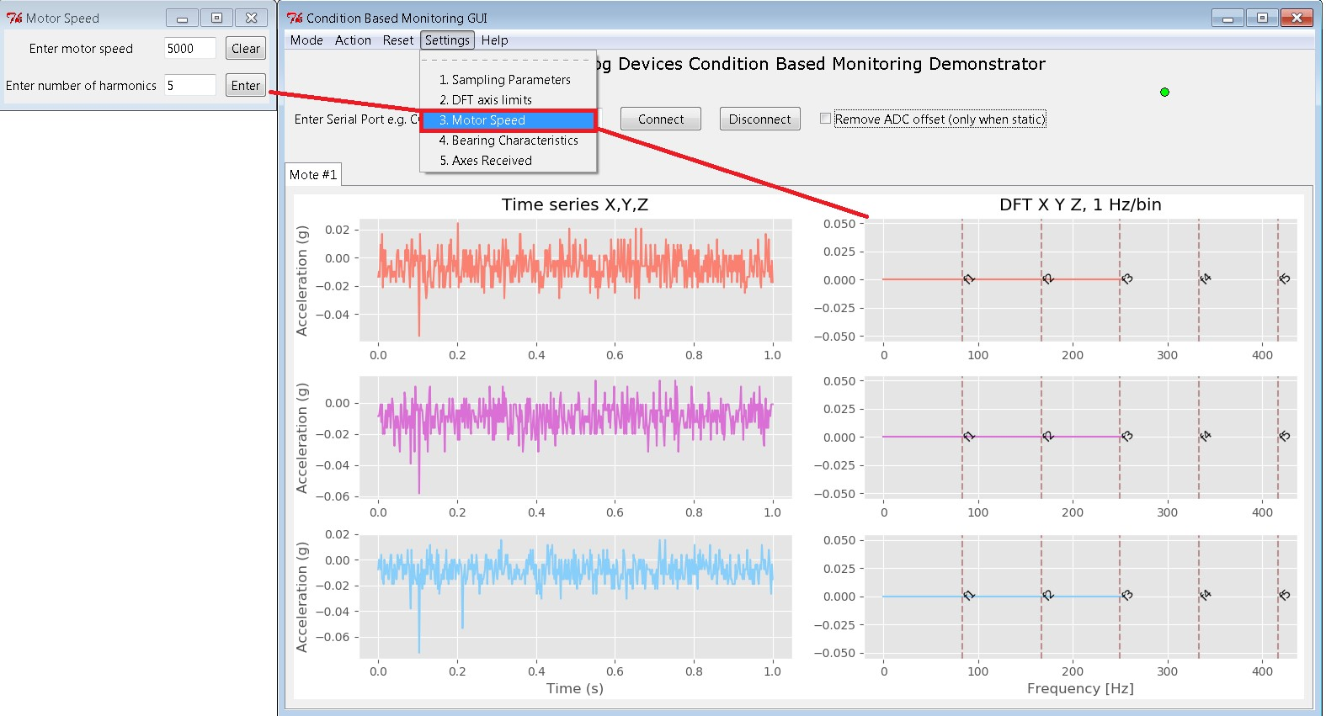

*Figure 23: Motor Speed Markers*

*Bearing markers*

This option allows user to fill in some information on the bearing characteristics of the vibration source being measured, which are used to calculate the expected frequencies of inner and outer bearing defects. These are marked on the DFT plot to indicate the frequencies bearing faults would occur at if present.

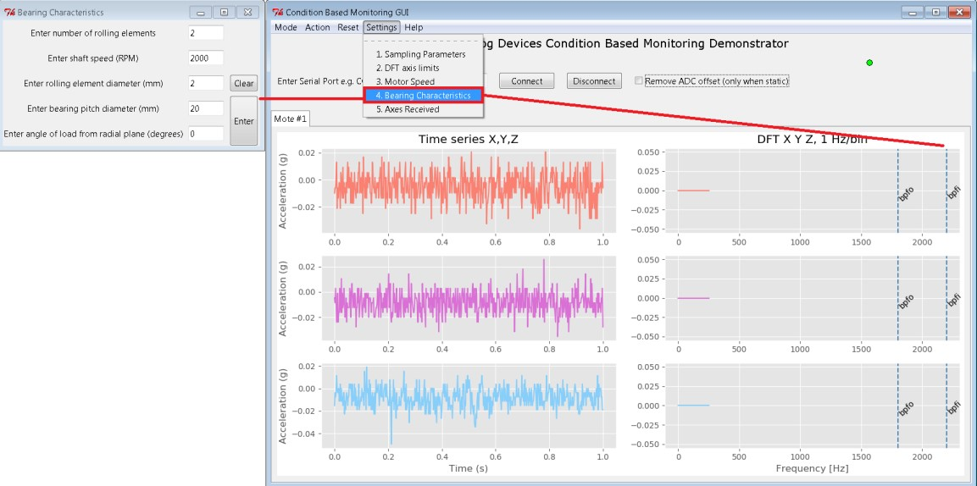

*Figure 24: Bearing Fault Markers*

*Axes Received*

This list of options allows the user to select which accelerometer axis information is sent by the mote. Any combination of axes can be sent together. This allows for faster sending of individual axes, if the user is not interested in seeing X, Y and Z data for the mote.

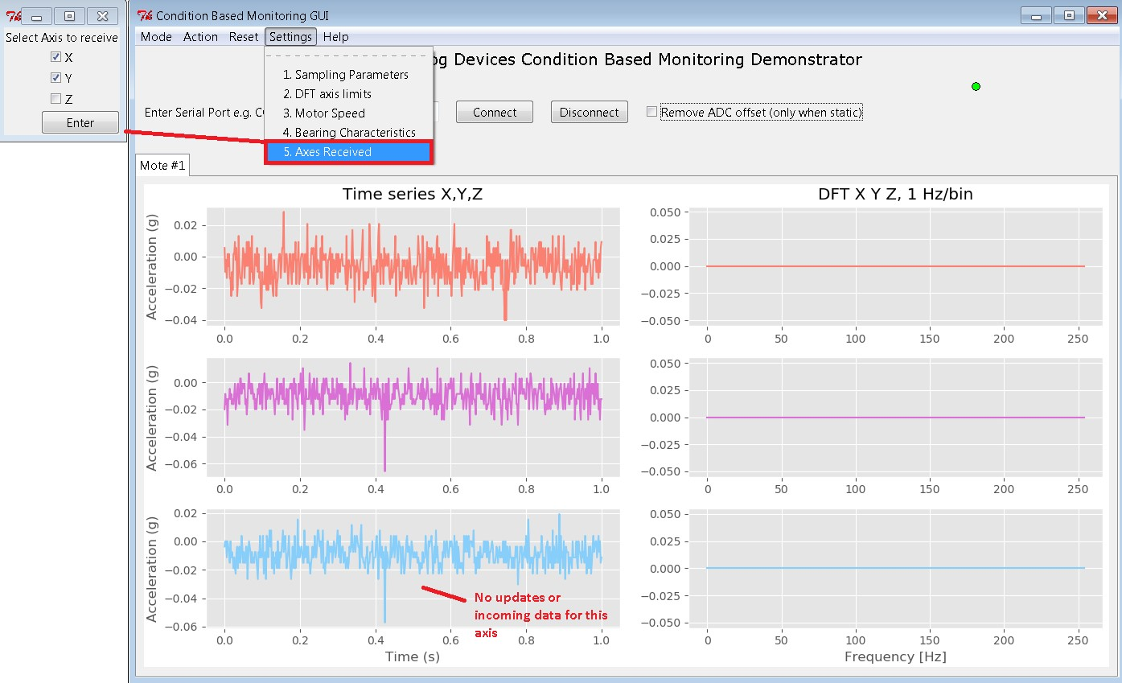

*Figure 25: Axes Received*

### Help

“Help” is a dropdown which provides a small amount of information on the functionality of the software. It also provides detailed information about the network of the manager and motes. Click “Network Info” to get information about the network, or “CBM Help” to get information about the program.

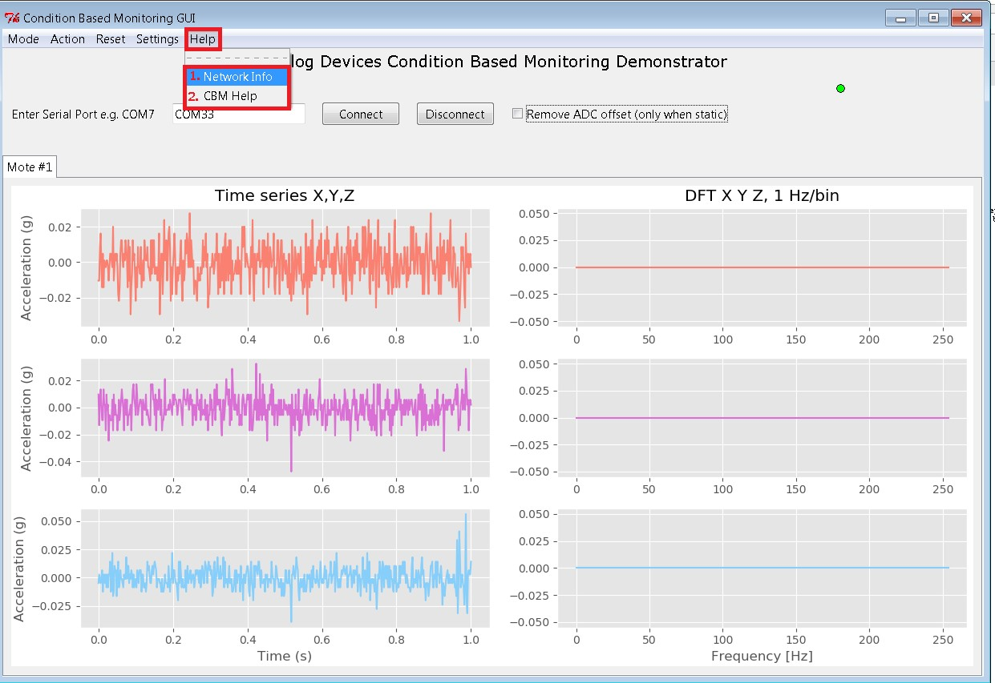

*Figure 26: Help Options*

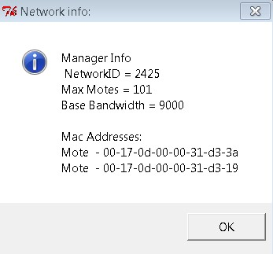

*Figure 27: Network Info Popup*

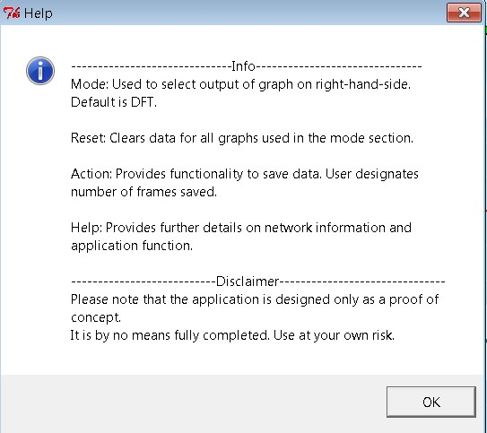

*Figure 28: Help Popup*

## Command Window

When the program is launched, the CBM Graphical User Interface (GUI) is launched, alongside a blank window, which may be different in colour depending on how the program was started. This is the command window.

Upon connecting, the command window displays some connected messages, in addition to the mac addresses of the connected motes.

During the runtime of the program, the command window displays further information about when and which packets are being received by the manager.

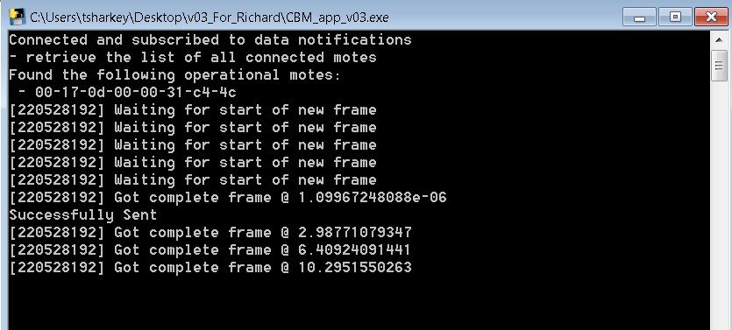

*Figure 29: Command window during program operation*

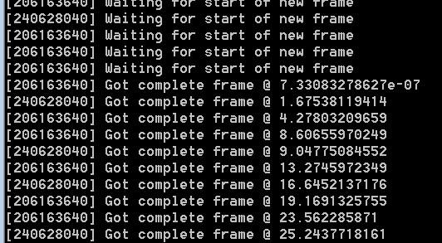

*Figure 30: Program when frames are correctly received*

# Support

## Installing updates

The motes that have been sent to you are capable of being updated via software (hex files), that will be sent to you from Analog Devices. There are a number of steps that must be taken in order to ensure these update are installed correctly, outlined below.

### Crosscore

Crosscore is an Analog Devices program that can be used to flash to a device if the user has a hex file. It can be downloaded for free [here](http://www.analog.com/en/design-center/processors-and-dsp/evaluation-and-development-software/crosscore-utilities.html#dsp-overview) (or look up Analog Devices Crosscore Utilities).

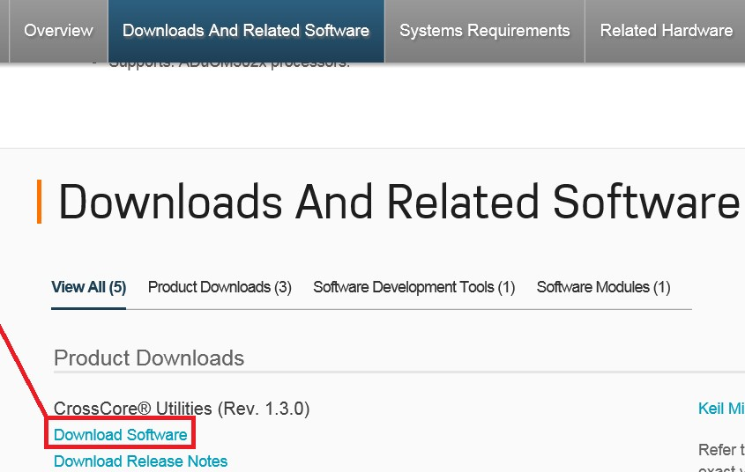

Next, hit run and follow the instructions for installing the software.

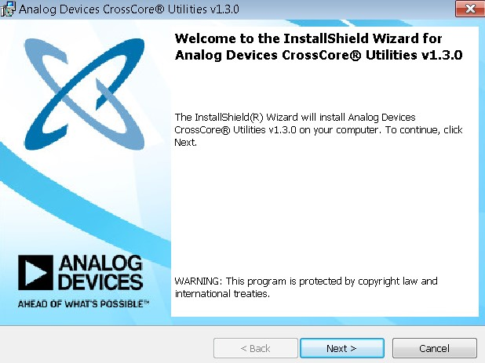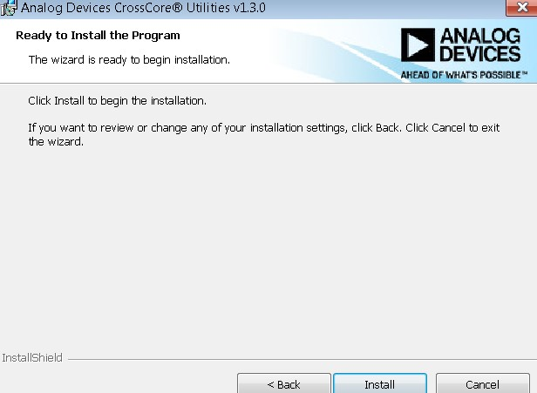

### Hex File

* A hex file will be included in the installed package, in the folder “Hex Files”
* It must be saved to your computer somewhere you will be able to find it.

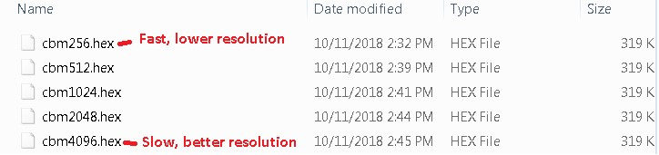

### Installing and resetting the mote

* It is useful for this section to have two pens or other narrow implements that can be used to press two small buttons on the programming board.
* First, make sure the USB end of the JLINK cable is plugged in to your computer.

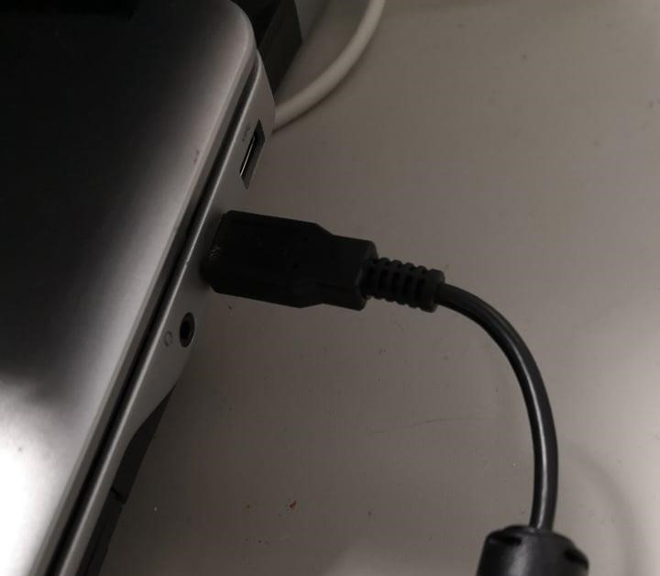

*Figure 31: JLINK - USB to computer*

* In order to program the microcontroller board, it must first be released from its vertical position on the mote. This is accomplished by sliding the board up and gently pulling it away from the casing.
* Ensure the boards are securely connected and power is supplied to the microcontroller board.

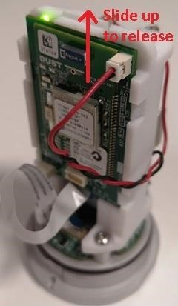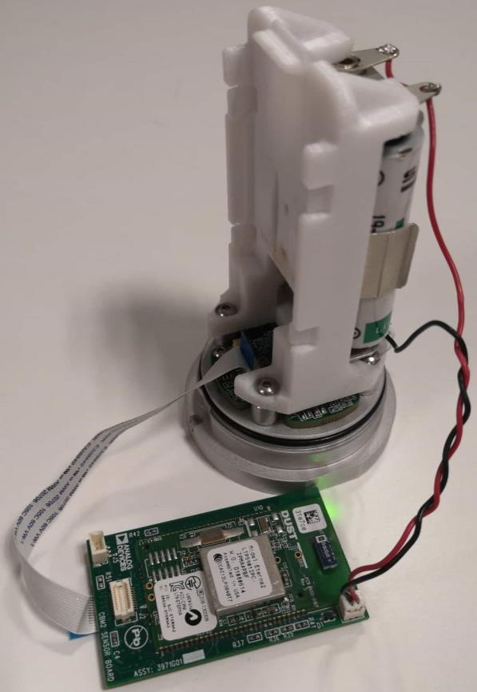

*Figure 32: Release board Figure 33: Board Removed*

* To put the mote in “Flash” mode, the programming board must be attached to the microcontroller board and secured with a clamp.

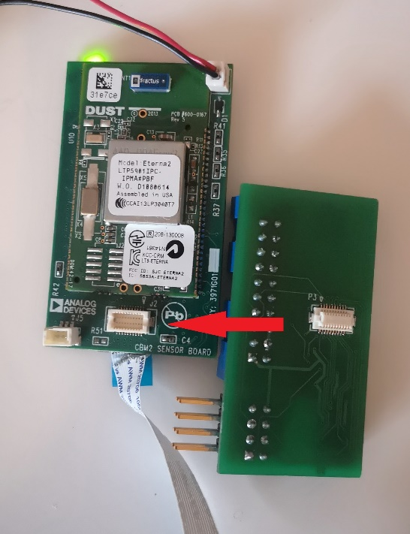 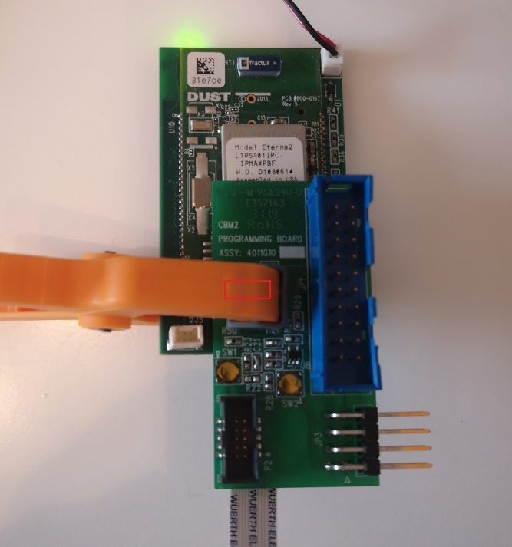

Figure 34: Attaching Programming and MCU board Figure 35: Clamped Programming and MCU board

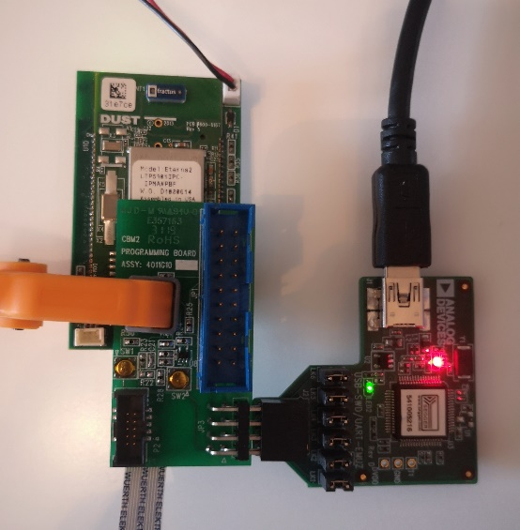

Figure 36: Connecting Segger Board and Programming Board

* Note, the mote must be powered while these steps are taking place. The power has been removed in Fig.37 to make the connections and buttons easier to see.
* Now the two golden buttons on the programming board as shown in Fig.37, FLASH (SW1) and RESET (SW2), must be pressed in a specific fashion to enter “Flash” mode.
* FLASH must be held down while RESET is **pressed and released**.
* FLASH can then also be released.
* If done correctly, the **green LED should remain off** when both buttons are released.

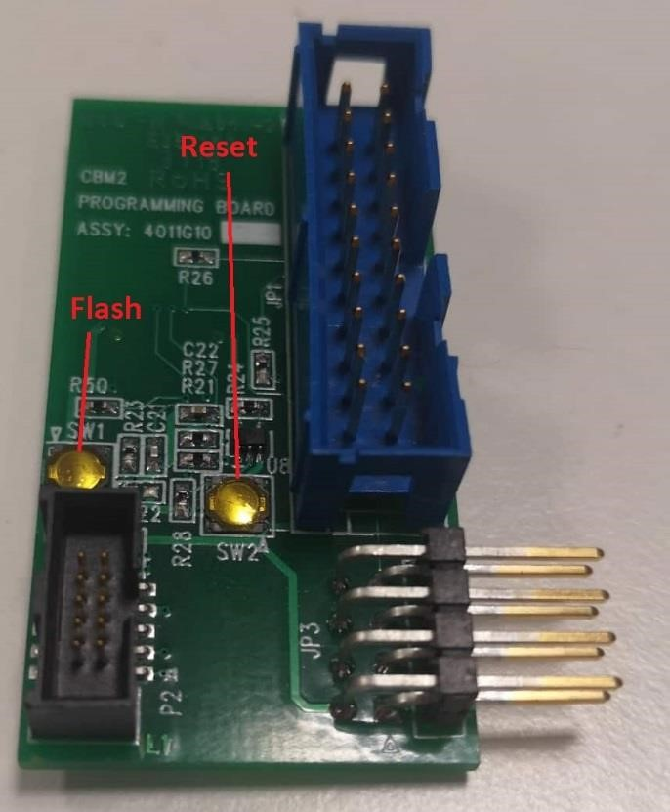

*Figure 37: Programming Board Flash and Reset Buttons*

### Putting it all together

Search for and open the crosscore program on your computer. A screen like what is shown below should open. Some options may be selected for you, but for the sake of clarity, we will go through each step.

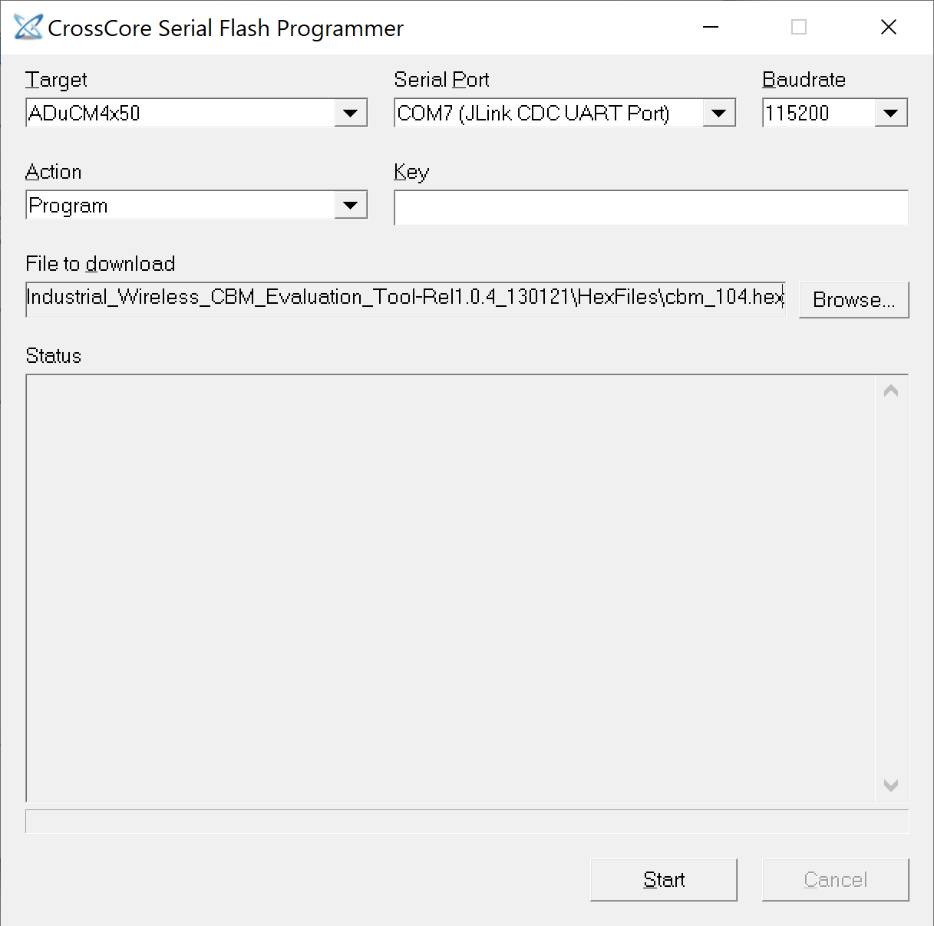

*Figure 38: CrossCore setup*

* For the “Target” selection box, select the ADuCM4x50.
* Connect the JLINK cable to your mote as shown and the USB to the USB port of your computer.
* You should now be able to select the JLINK port in the “Serial Port” menu of the crosscore program.
* For “Baudrate”, select 115200.
* For “Action” select Program.
* Leave “Key” blank.
* For “File to download”, browse for and select the hex file you have downloaded, wherever it may be on your computer.
* The program is now ready to be loaded onto your mote.
* Click “Start” in the bottom right corner. You should see some loading and a load complete message as shown. You can now close this window.

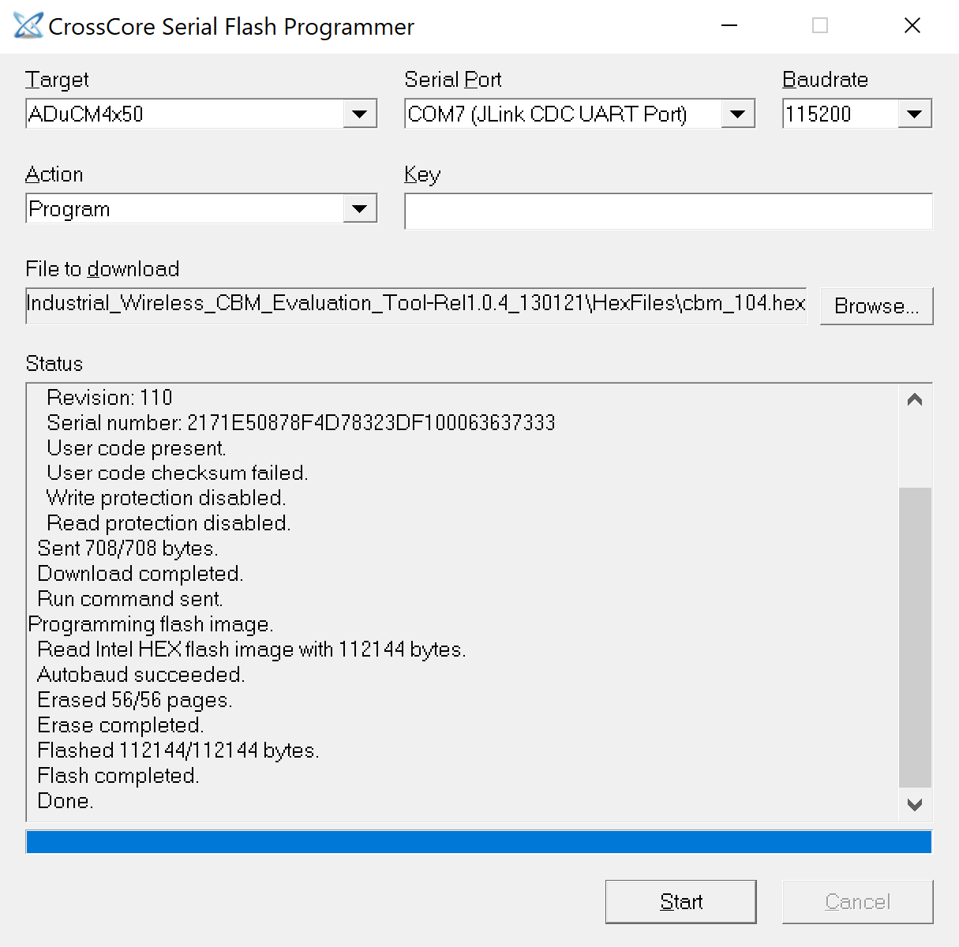

*Figure 39: Completed CrossCore*

* Please note, the mote must now be RESET. This is done be pressing the SW2 button as indicated in Fig.34.
* The green light should blink to life.

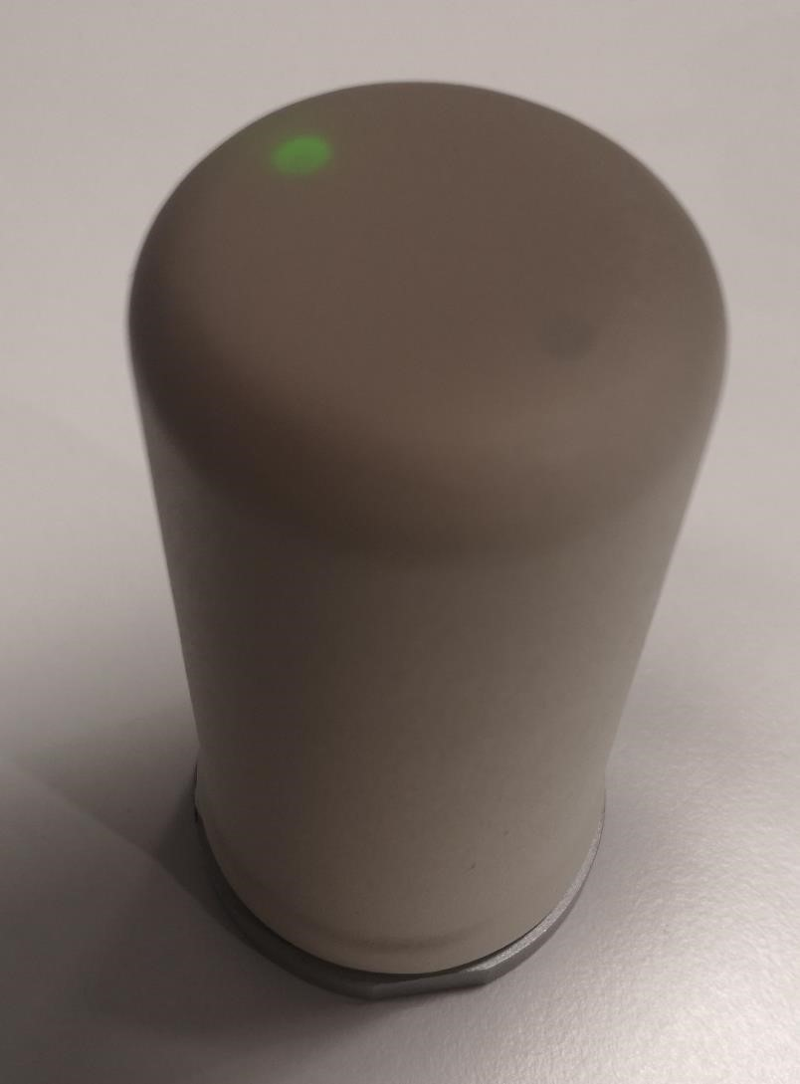

*Figure 40: Mote after reset*

* You have now successfully updated the mote.

## Mounting Information

The Voyager enclosure includes a ¼-28 threaded hole. To mount the mote, either a mounting stud or a magnetic mount can be used. Magnetic mounts are typically used in situations where the monitored equipment does not include a threaded hole. Several different scenarios for mounting are discussed below, with suggested parts for each scenario.

### Mounting Studs

If the monitored equipment includes a **¼-28 threaded hole**, then a ¼-28 to ¼-28 attach stud can be used. Options include the following.

* CTC: MH108-1B: [<https://www.ctconline.com/mounting_studs.aspx?prd=MH108-1B>]
* PCB Piezotronics 081B20 [<https://www.pcb.com/products?m=081B20>]

If the monitored equipment includes an **M6 threaded hole**, then a ¼-28 to M6 attach stud can be used. Options include the following.

* CTC: MH108-5B: [<https://www.ctconline.com/mounting_studs.aspx?prd=MH108-5B>]
* M081B20 Metric mounting stud, ¼-28 to M6 x 0.75, BeCu w/shoulder: [<https://www.pcb.com/products?m=M081B20PCB>]

If the monitored equipment includes an **M8 threaded hole**, then a 1/4 -28 to M8 attach stud can be used. Options include the following.

* MH108-6B: [<https://www.ctconline.com/mounting_studs.aspx?prd=MH108-6BCTC>]

### Magnetic Mounts

IFM and PCB Piezotronics provide magnetic mounts with M8 or ¼-28 vibration sensor attach.

* IFM M8 attachment flat E30448 [<https://www.ifm.com/ie/en/product/E30448?tab=details>]

Note: To use the IFM base then you also need a ¼-28 to M8 adaptor stud for the Voyager enclosure

* PCB Piezotronics ¼-28, both flat and curved surface attachment [<https://www.pcb.com/sensors-for-test-measurement/accelerometers/accessories/magnetic-mounting-bases>]. Note: The Piezotronics bases 080A54, 080A130/131/132 could be used directly with the Voyager enclosure concept, as they include a ¼-28 threaded hole.

## Troubleshooting

Note:

(1)

The CBM application does not currently run with Serial Mux installed on your computer. If serial mux is installed on your computer, it must be suspended or removed in order for CBM to run. Further info can be found in the [SmartMesh IP Tools Guide.](http://www.analog.com/media/en/technical-documentation/user-guides/SmartMesh_IP_Tools_Guide.pdf) This guide also mentions Stargazer, an application to view the network topology. This is not needed for the CBM_app but provides a visual demonstration of the network.

(2)

Many changes in the app do not occur instantly. If the executable setup is used, the user should expect to wait a while in order for the program to gather all of the libraries it depends on. During this time, the program will appear as a blank command prompt.

*Q: I have completed setup but the mote’s light is not blinking.*

A: This problem indicates that the network between the mote and manager has not been established. The network between these two pieces of hardware forms automatically. **Connecting the manager before the mote** should help ensure this network forms correctly.

Alternatively, this may be an issue with the network ID’s of the manager and mote. You may refer to another troubleshooting question: “*Q: I have purchased my own manager. Why can’t I connect?* “. This will guide you in resetting the network ID of your manager to match that of your mote.

*Q: The application is running, but the data does not appear to change when I move the mote.*

A: Try shaking vigorously and ensure that the mote is being shaken in the direction of an accelerometer axis, X, Y or Z for best results.

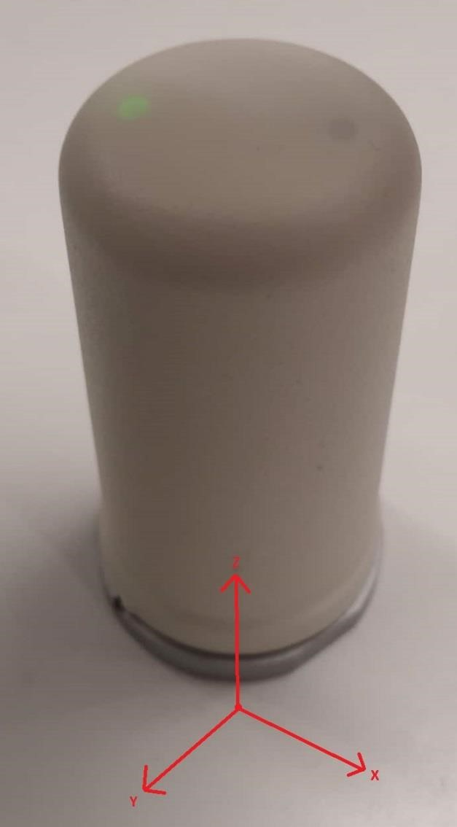

*Figure 41: Axis of acceleration*

*Q: My computer cannot find pip to install python modules.*

A: Python versions below 2.7.9 do not install the pip package manager by default. If you have navigated correctly to the folder Python27 > Scripts, opened the command window in that folder, and pip is not a recognised command, python should be reinstalled. Ensure the version you download is 2.7.15. After you have completed installation, repeat the steps marked in **Pip Installations** . If this problem persists, consult the documents on installing pip [here.](https://github.com/BurntSushi/nfldb/wiki/Python-%26-pip-Windows-installation)

*Q: How can I save data to an Excel file without saving to a SQL database first?*

A: In the current version of the code this feature does not exist. If you attempt to “Convert to Excel” without first saving to SQL by pressing “Enter”, an error will occur. This is because it is more efficient in terms of memory and performance to first save to SQL and convert to excel afterwards.

*Q: I am getting a version mismatch error.*

A: The Python program and the firmware for each mote have an agreed version to ensure that new code is not used with old firmware. If the GUI displays a version mismatch error, either the GUI or the firmware being used is outdated. It is best to update the Python GUI and the firmware being used to the newest version.

*Q: I have purchased my own manager. Why can’t I connect?*

A: The mote that has been shipped to you has been set to a network ID which cannot be changed. In order for the mote and manager to communicate, the network ID of the manager must be changed. The steps to do this are outlined below:

* Download [TeraTerm](https://osdn.net/projects/ttssh2/releases/) or [puTTY](https://www.chiark.greenend.org.uk/~sgtatham/putty/latest.html) if they are not already installed on your computer.

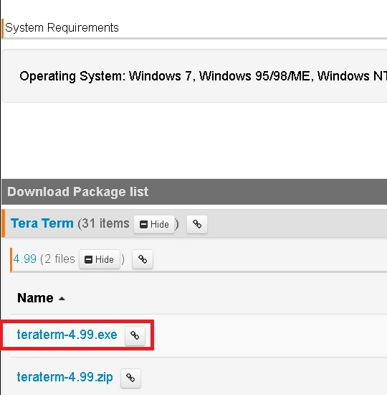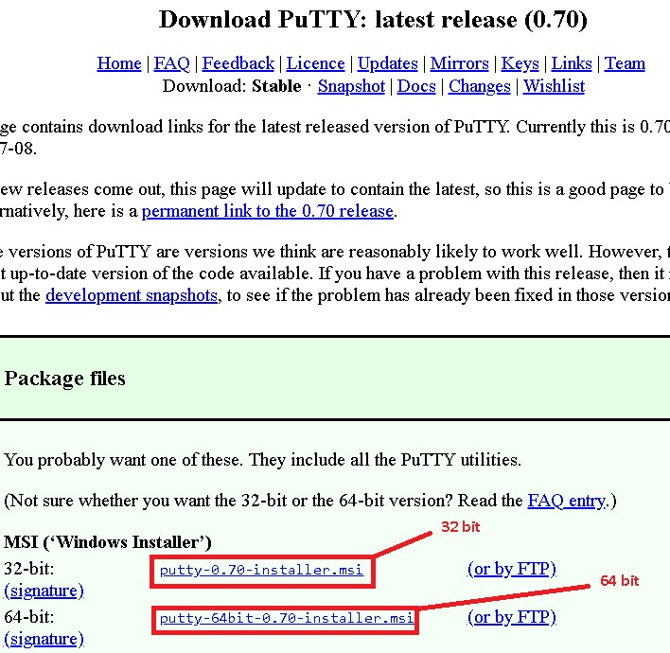

* Ensure your manager is connected via USB.

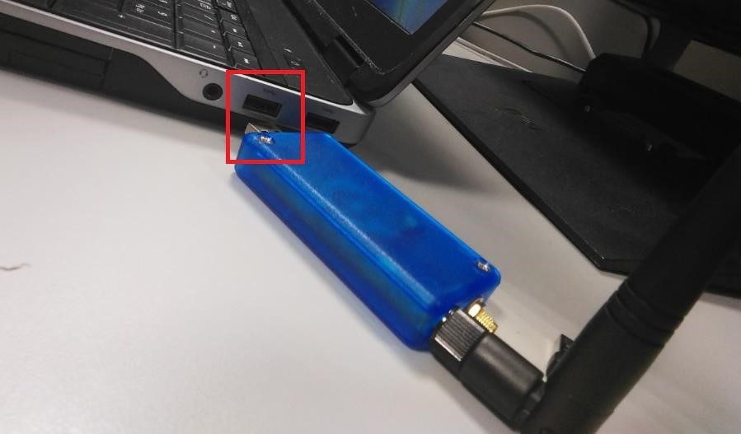

* If you chose TeraTerm, open the program and go to File -> New connection

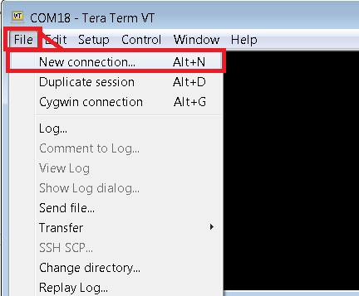

* Select the serial option presented in the “new connection”
* The serial port you must use is the 3rd of the 4 numbers that the manager occupies (see Hardware setup if you do not know which COM port to use).
* Choose this option in the Port selection box (shown below).

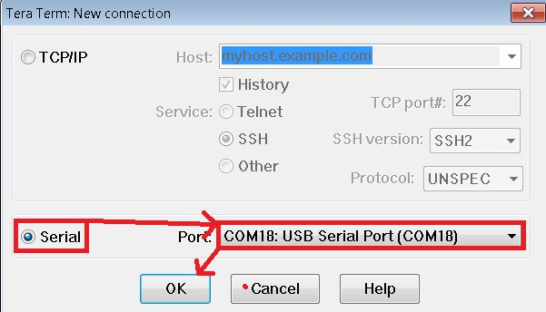

* Click ok.
* In puTTY, select serial and enter the serial port as the 3rd of the 4 numbers that the manager occupies (see Hardware setup if you do not know which COM port to use).

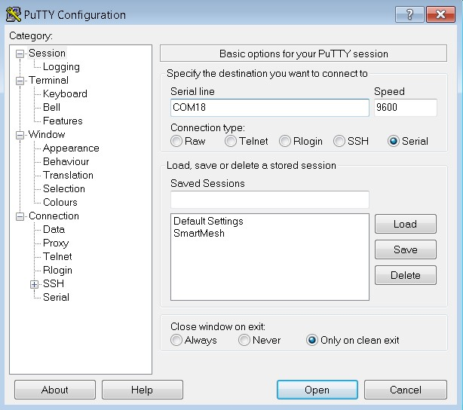

* Click open.
* Whether you chose puTTY or TeraTerm, this opens a command prompt. • Type in “login user” and hit enter.

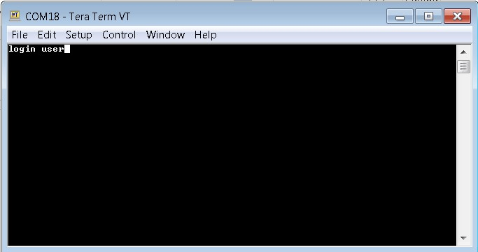

* Type “minfo” to display information about the manager.

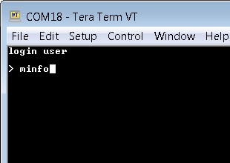

* Enter “set config netid=2425” to change the network ID of the manager to 2425, the same

as the in-built network ID of the mote.

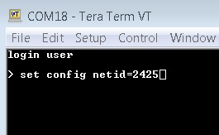

* Enter “reset system” to save the changes you have made. Wait until the message “Ready is displayed as shown.

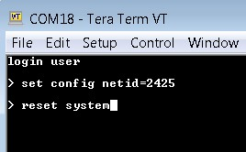

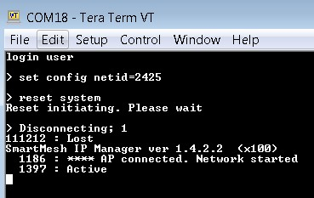

* Type “minfo” again to verify that the network ID has been correctly changed.

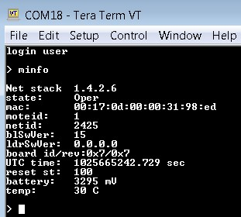

* The manager has now been updated. If the manager is powered before the mote, a connection will be established.